

SGM C304 bootloader programming guide
By I2C Interface

Revision 1.0.3

Tables of Content

Revision History 2
1. Program the Application Memory Process by I2C Interface 3
2. The Bootloader State Machine Process 4
3. The ECU Memory Assignment 4
3.1. Customer ID Format 4
4. Program Rules 5
5. I2C Protocol Definition 7
5.1. I2C Write Format 7
5.2. I2C Read Format 7
6. Program Commands Set 7
6.1. The IRQ Signal Control (0xC3) 7
6.1.1. Command Packet Format 7
6.2. Bootloader Status Get (0x80) 7
6.2.1. Bootloader Status Flags 8
6.2.2. IRQ Status Flags 9
6.2.3. Command Packet Format 9
6.3. FIDM Program Update (0x34) 9
6.3.1. Command Packet Format 10
6.4. The APP Memory Unlock (0x84) 10
6.4.1. Command Packet Format 10
6.5. The APP Memory Erase (0x88) 10
6.5.1. Command Packet Format 10
6.6. Write Flash Page (0x8D) 11
6.6.1. Command Packet Format 11
6.7. Force Reset the FIDM (0x31) 11
6.7.1. Command Packet Format 11

Revision History

Date | Version | Change(s) | Author(s)
2020/03/12 | 0.0.1 | This version was changed with the following modifications,  - Bootloader programming guide for SGM project. | Fenderson Lu
2020/04/08 | 0.0.2 | Modify List:  - Modify tables and add I2C protocol format.  - Delete 50ms interval time every packet description.  - Modify program rules description and other. | Fenderson Lu
2020/08/05 | 0.0.3 | Modify List:  - Delete commands.  - Add 0x80 data packets.  - Modify program flash flowchart.  - Modify program rules.  - Modify memory assignment.  - Modify Reset MCU command 0x40 to 0x31. | Fenderson Lu
2021/02/18 | 1.0.0 | Generate PDF document. | Fenderson Lu
2021/03/19 | 1.0.1 | Modify List:  - Modify flash keys 2 bytes to 4 bytes, and follow access keys.  - Modify Byte name.  - Modify PROGRAM_UPDATE_0x44 to 0x34 command. | Fenderson Lu
2021/06/30 | 1.0.2 | Modify List:  - When APP to BL mode, waiting time is changed from 1s to 3s. | Fenderson Lu
2021/07/02 | 1.0.3 | Modify List:  - Update bootloader program flowchart.  - Add delay condition in the host is programming.  - Update start-up check flowchart. | Fenderson Lu

Program the Application Memory Process by I2C Interface
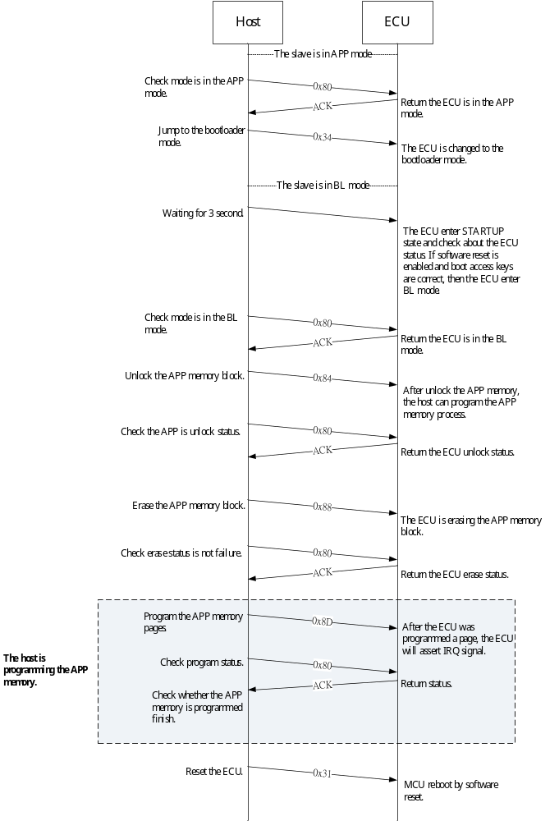

The Bootloader State Machine Process
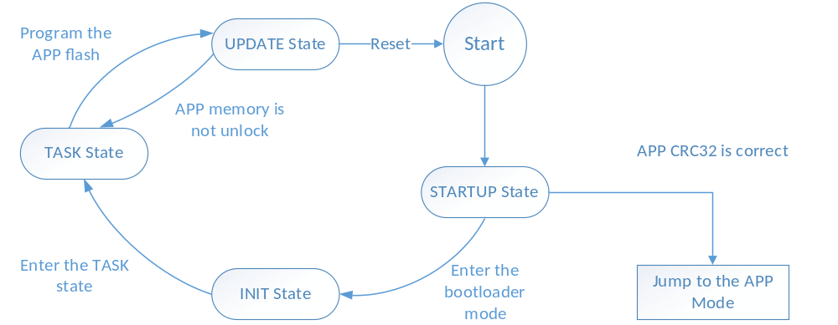

The ECU Memory Assignment
Memory Area | Address |  |  | Length (Bytes) |  | Size |  | Total Size
APP | APP Code | 0x4000 ~ 0x13FFF | 65504 |  | 63.9KB |  | 64KB
APP | Customer ID | 0x13FE0 ~ 0x13FE7 | 8 |  | 8B
APP | ECU Version | 0x13FF0 ~ 0x13FF7 | 8 |  | 8B
APP | ECU CRC32 | 0x13FFC ~ 0x13FFF | 4 |  | 4B
BL | BL Code | 0x0000 ~ 0x3FFF | 16384 |  | 16KB |  | 16KB

Customer ID Format
 | [Byte 0] | [Byte 1] | [Byte 2] | [Byte 3] | [Byte 4] | [Byte 5] | [Byte 6] | [Byte 7]
Hex | 0x41 | 0x55 | 0x4F | 0x26 | 0x53 | 0x47 | 0x4D | 0xFF
ASCII | A | U | O | & | S | G | M
[PS]:
- “0xFF” is not used.
- The AUO ID are byte0 ~ byte2.
- The customer ID are byte4 ~ byte7.

Program Rules
  - Program the APP memory page is 64-bytes. If Data < 64-bytes, then other unused data fill “0xFF”.
  - The APP memory size is 64KB; the BL memory is 16KB.
  - The APP CRC32 calculation range are APP vectors, APP flash configure and APP code.
  - The ECU has not received any commands, then timeout and change state from UPDATE to TASK state.
  - About access the APP memory commands need load boot keys and CRC16 check. Commands set below:
      - Bootloader Status (0x80): Packets + CRC16.
      - Unlock Application Memory (0x84): Packets + Flash Keys + CRC16.
      - Erase Application Memory (0x88): Packets + Flash Keys + CRC16.
      - Write Flash Page (0x8D): Packets + Flash Keys + CRC16.
  - Data packets order are the left of packet is the Least Significant Bit (LSB), the right of packet is the Most Significant Byte (MSB).
  - Once the host send I2C write commands, the ECU will set the IRQ assert. The host need send release IRQ command to the ECU. But the Force Reset the FIDM command (0x40) of the ECU doesn’t set IRQ assert signal.
  - The bootloader mode will assert the IRQ on any change to the bootloader status. The IRQ will be cleared once this bootloader status is read.
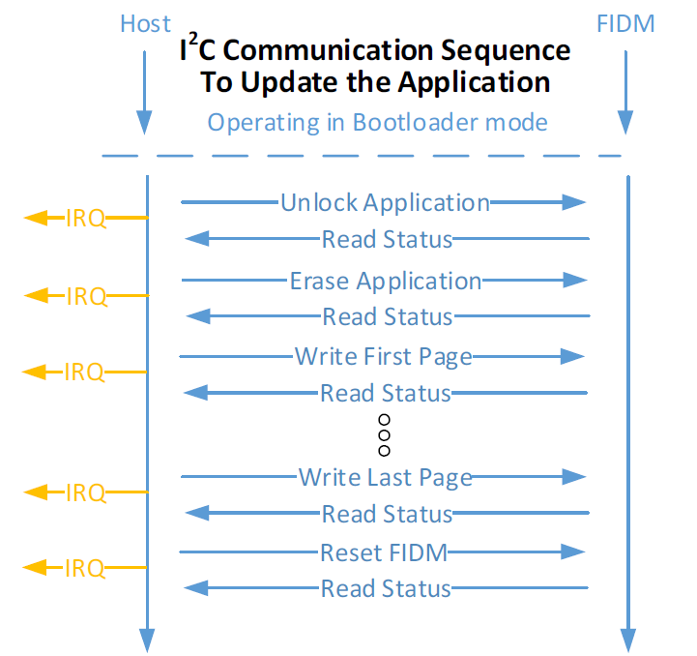
  - Need delay moment when the host send packets below：
- Delay 1 second after the host send APP memory unlock 0x84 command and program last page packets.
- While the host is programming the FIDM device, the host send Bootloader Status Get 0x80 command after delay 15ms ~ 25ms command.
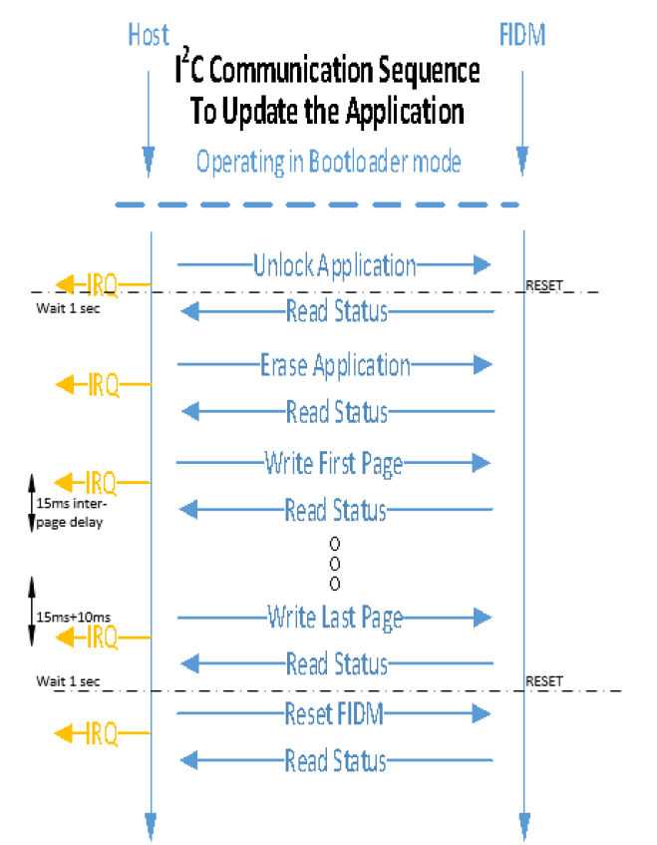

  - The bootloader startup process below:
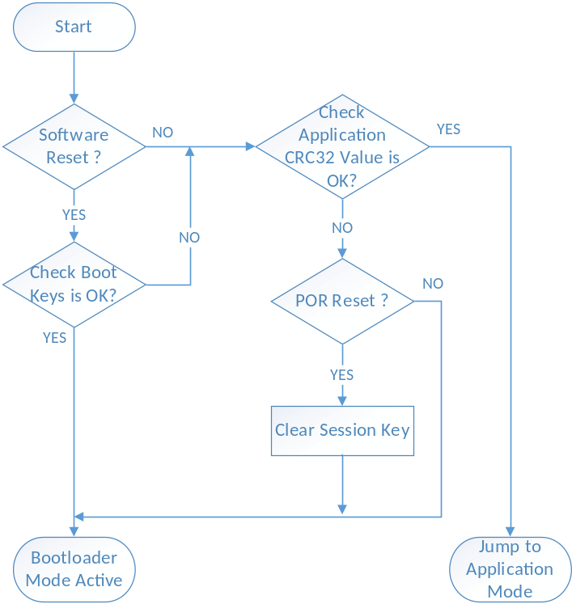

I2C Protocol Definition
The ECU slave address is 0x32 (7-bits).

I2C Write Format
START | [Byte 0] | [Byte 1] | [Byte 2] | [Byte (n-1)] | STOP
START | Slave Address | Command | Data 0 | Data (n-1) | STOP

I2C Read Format
START | [Byte 0] | [Byte 1] | STOP
START | Slave Address | Command | STOP

Program Commands Set

The IRQ Signal Control (0xC3)
If the ECU IRQ signal is asserted, the host need send command to the ECU release IRQ signal.

Command Packet Format
IRQ Control Flags
Bit | Description
7 ~ 2 | Reserved.
1 | 1 = The IRQ signal set release.
0 | Reserved.

- The Host Send
[Byte 0] | [Byte 1]
Command | IRQ Control Flags
1 Byte | 1 Byte

- The ECU ACK
No ACK.

Bootloader Status Get (0x80)
The host read bootloader status. If IRQ assert, mean the ECU Bootloader Status flags has changed, then the host will check Bootloader Status flags.

Bootloader Status Flags
Bootloader Status 1 Flags
Bit | Description
7 | 0 = Voltage is normal.  1 = Voltage is abnormal.
6 | 0 = CRC16 is correct.  1 = CRC16 is failure.
5 | 0 = Erase key is correct.  1 = Erase key is failure.
4 | 0 = Session key is correct.  1 = Session key is failure.
3 | 0 = Flash writes failure.  1 = Flash writes successful.
2 | 0 = Application memory hasn't erased.  1 = Application memory erased.
1 | 0 = Application memory locked.  1 = Application memory unlocked.
0 | 0 = Application mode active.  1 = Bootloader mode active.

Bootloader Status 2 Flags
Bit | Description
7 | Reversed.
6 | Reversed.
5 | Reversed.
4 | Reversed.
3 | Reversed.
2 | Reversed.
1 | 0 = No unknown error.  1 = Unknown error.
0 | 0 = Programming pass.  1 = Programming error.

IRQ Status Flags
IRQ Status
Bit | Description
7 ~ 1 | Reserved.
0 | 0 = The IRQ signal is released.  1 = The IRQ signal is asserted.

Command Packet Format
- The Host Send
[Byte 0]
Command
1 Byte
- The ECU ACK
[Byte 0] | [Byte 1] | [Byte 2] | [Byte 3] | [Byte 4]
Bootloader Status 1  Flags | Bootloader Status 2  Flags | IRQ Status  Flags | CRC16  Low Byte | CRC16  High Byte
1 Byte | 1 Byte | 1 Byte | 2 Bytes

FIDM Program Update (0x34)
The host need send the 3 packets of boot and session keys to the ECU, let the ECU jump mode from APP to PBL mode. When the ECU into bootloader mode, the session key will clear to 0x0000. Send boot and session keys packets order are:
- Boot Access Key 0 = 0x55AA (2 Bytes)
- Boot Access Key 1 = 0x33CC (2 Bytes)
- Session Key = 0xFFFF (2 Bytes)
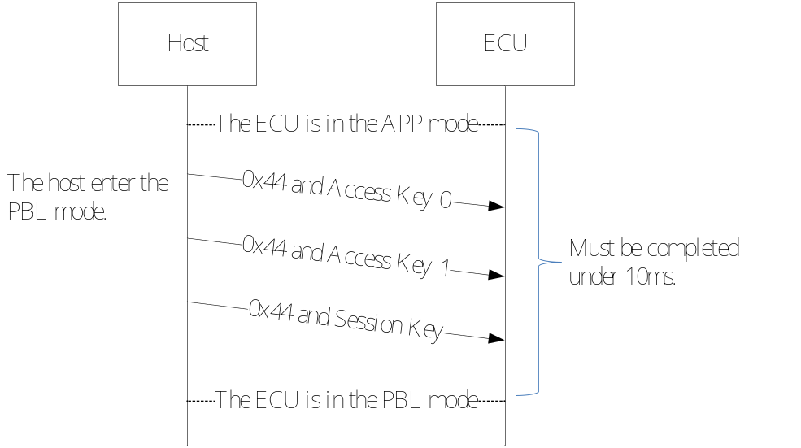

Command Packet Format
- The Host Send
[Byte 0] | [Byte 1] | [Byte 2]
Command | Key Low Byte | Key High Byte
1 Byte | 2 Bytes

- The ECU ACK
No ACK.

The APP Memory Unlock (0x84)
The ECU unlock the APP memory block, the host can program the APP memory block.

Command Packet Format
- The Host Send
[Byte 0] | [Byte 1 - 4] |  |  |  | [Byte 5] | [Byte 6]
Command | Boot Key 0  Low Byte | Boot Key 0  High Byte | Boot Key 1  Low Byte | Boot Key 1  High Byte | CRC16 Low Byte | CRC16 High Byte
1 Byte | 4 Bytes |  |  |  | 2 Bytes

- The ECU ACK
No ACK.

The APP Memory Erase (0x88)
The host need erase the APP memory block before program.

Command Packet Format
- The Host Send

[Byte 0] | [Byte 1 - 4] |  |  |  | [Byte 5] | [Byte 6] | [Byte 7]
Command | Boot Key 0  Low Byte | Boot Key 0  High Byte | Boot Key 1  Low Byte | Boot Key 1  High Byte | 0xA5 | CRC16 Low Byte | CRC16 High Byte
1 Byte | 4 Bytes |  |  |  | 1 Byte | 2 Bytes

- The ECU ACK
No ACK.

Write Flash Page (0x8D)
Waiting for IRQ signal trigger after the host send program commands. If the ECU is triggered IRQ signal mean flash write page are finish.
- A Page: 64-bytes.
- Boot Keys: Checking flash key 0 and 1 is correct, the ECU will program the APP memory block.
- Packet Number: Checking the host and the ECU every packet is synchronized.
- Data Length: Calculate program packet total length.
- Data: The bin file raw data.
- CRC16: Calculate CRC16 from Command to Bin Raw Data.

Command Packet Format
- The Host Send
[Byte 0] | [Byte 1 - 4] |  |  |  | [Byte 5 – 7] | [Byte 8 – 71] | [Byte 72 – 73]
Command | Boot Key 0  Low Byte | Boot Key 0  High Byte | Boot Key 1  Low Byte | Boot Key 1  High Byte | Flash Write  Address | Bin Raw  Data | CRC16
1 Byte | 4 Bytes |  |  |  | 3 Bytes | 64 Bytes | 2 Bytes

- The ECU ACK
No ACK.

Force Reset the FIDM (0x31)
When the ECU has programmed finish, the host sends reset ECU system command to the ECU, the ECU will reboot myself.

Command Packet Format
Force Reset the FIDM Flags
Bit | Description
7 ~ 2 | Reserved.
1 | 1 = The ECU reset.
0 | 1 = The touch controller reset.

- The Host Send
[Byte 0] | [Byte 1]
Command | Force Reset the FIDM Flags
1 Byte | 1 Byte

- The ECU ACK
No ACK.

